Ideation Phase
Define the Problem Statements

Date | 14 February 2026
Team ID | LTVIP2026TMIDS24417
Project Name | HematoVision: Advanced Blood Cell Classification Using Transfer Learning
Marks | 2 Marks

Customer Problem Statement:
Healthcare professionals, remote practitioners, and medical trainees need an accurate and efficient method for blood cell classification because manual analysis is time-consuming, error-prone, and inaccessible in many regions. This leads to delayed diagnoses, increased workload, and gaps in medical training and healthcare accessibility.
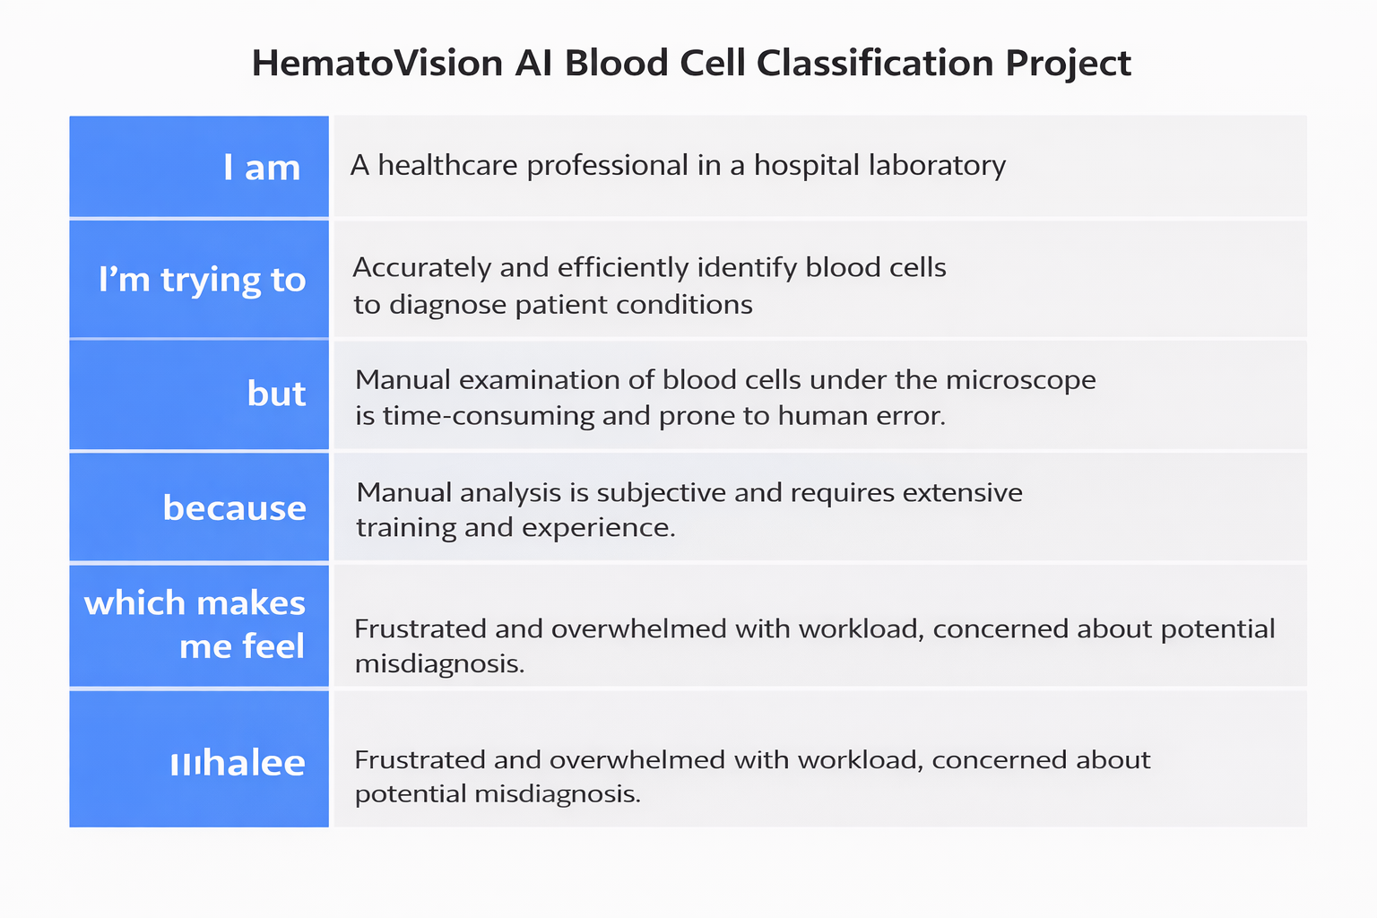
Example:
Problem Statement (PS) | I am (Customer) | I’m trying to | But | Because | Which makes me feel
PS-1 | A laboratory technician working in a hospital diagnostic center. | Accurately identify and classify different types of white blood cells from blood smear images to assist in early disease diagnosis. | Manual microscopic examination is time-consuming, repetitive, and prone to human error, especially when handling a large number of samples. | Cell morphology variations are subtle, require high expertise, and fatigue can reduce concentration and accuracy. | Overwhelmed, stressed about possible misdiagnosis, and concerned about delivering delayed or inaccurate results.
PS-2 | A healthcare institution aiming to improve diagnostic efficiency and accuracy. | Implement an automated and reliable system that can quickly classify blood cells with high accuracy. | Traditional methods rely heavily on skilled professionals and lack automation support. | There is limited AI integration in laboratory workflows, and manual processes slow down reporting time. | Restricted in scalability, concerned about operational efficiency, and motivated to adopt innovative AI-based solutions like HematoVision.

